Lab Activity 08 Worksheet
Place your screenshots and / or answers to questions here.

Part 1 Screenshot: Virtualization is on (2 points)
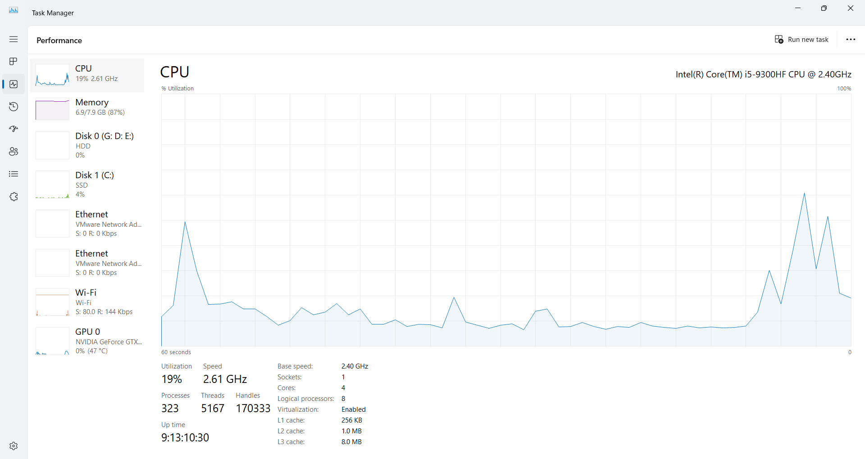

Part 2 Screen Shot: VM Ware with Virtual Machine Configured (2 points)
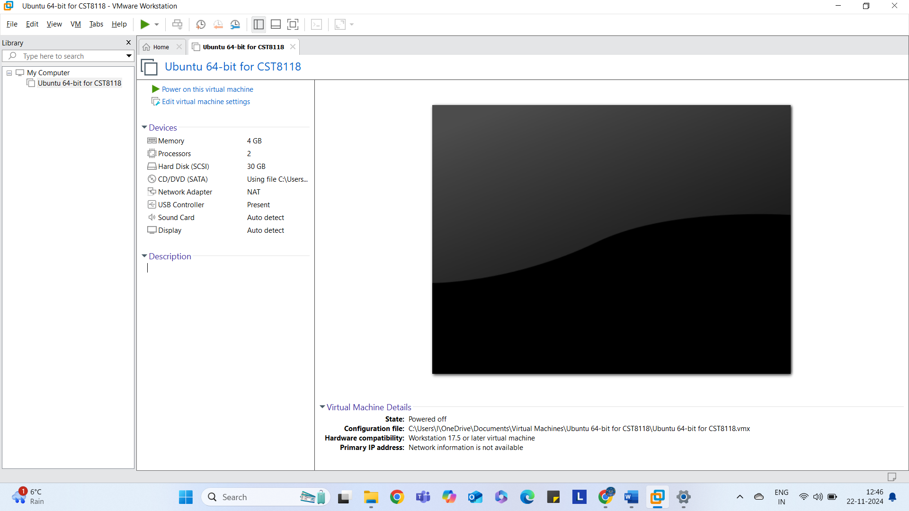

Part 3 Screen Shot: Ubuntu Linux booted up in Virtual Environment (2 points)
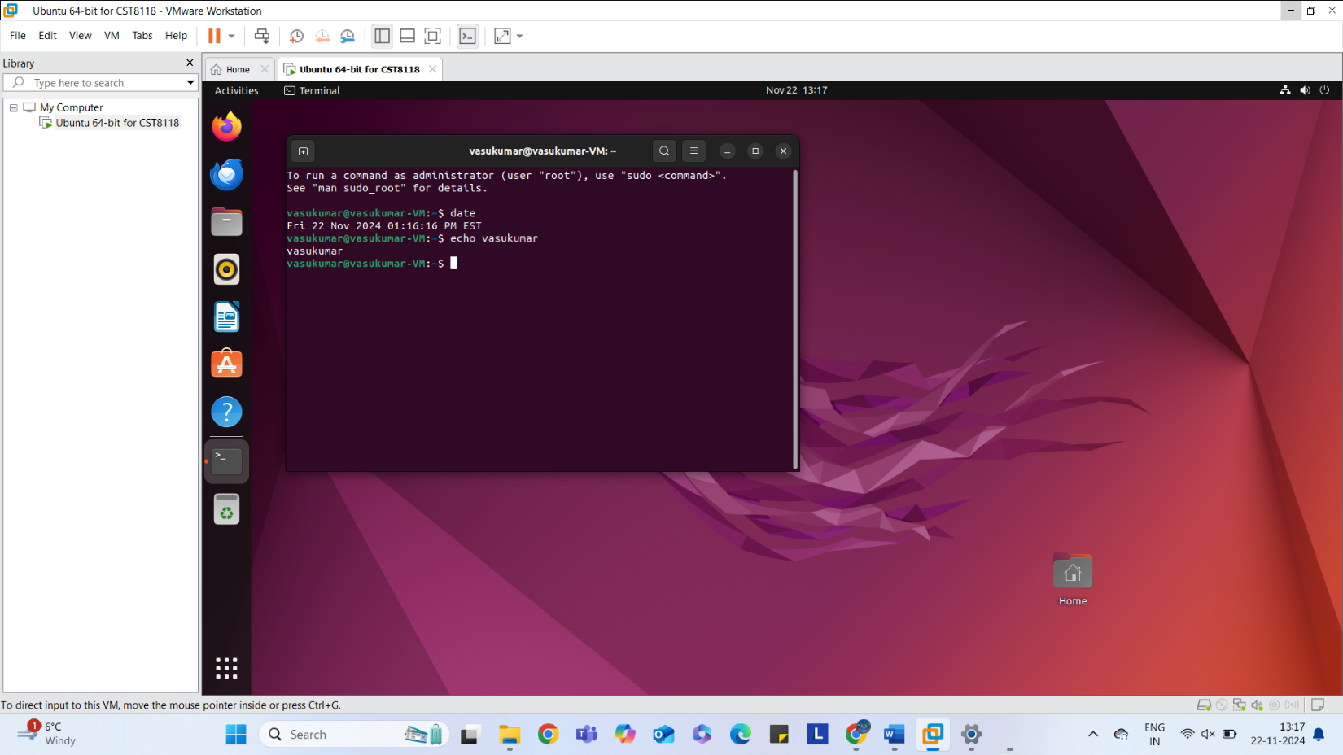

Part 4 Screen Shot: Changing Root password (1 point)
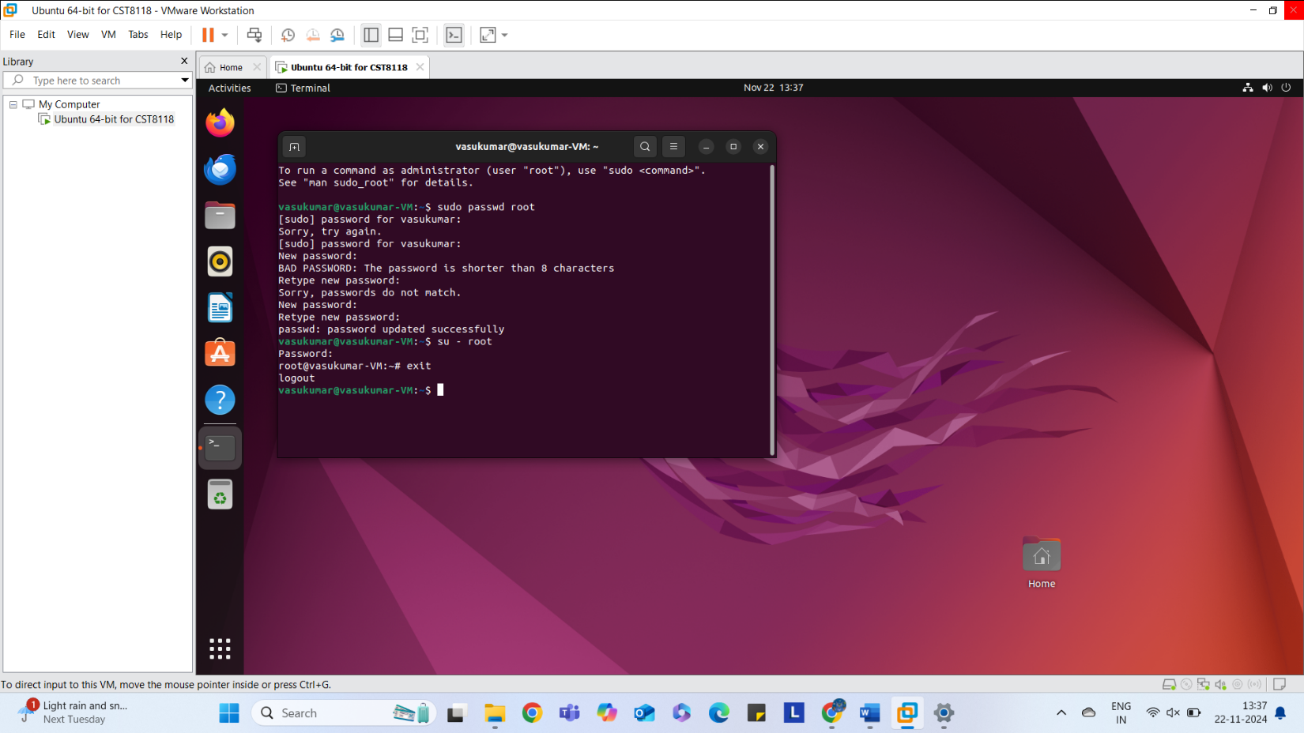

Part 5 Screen Shot: Version check VM Ware Tools Installed (1 point)
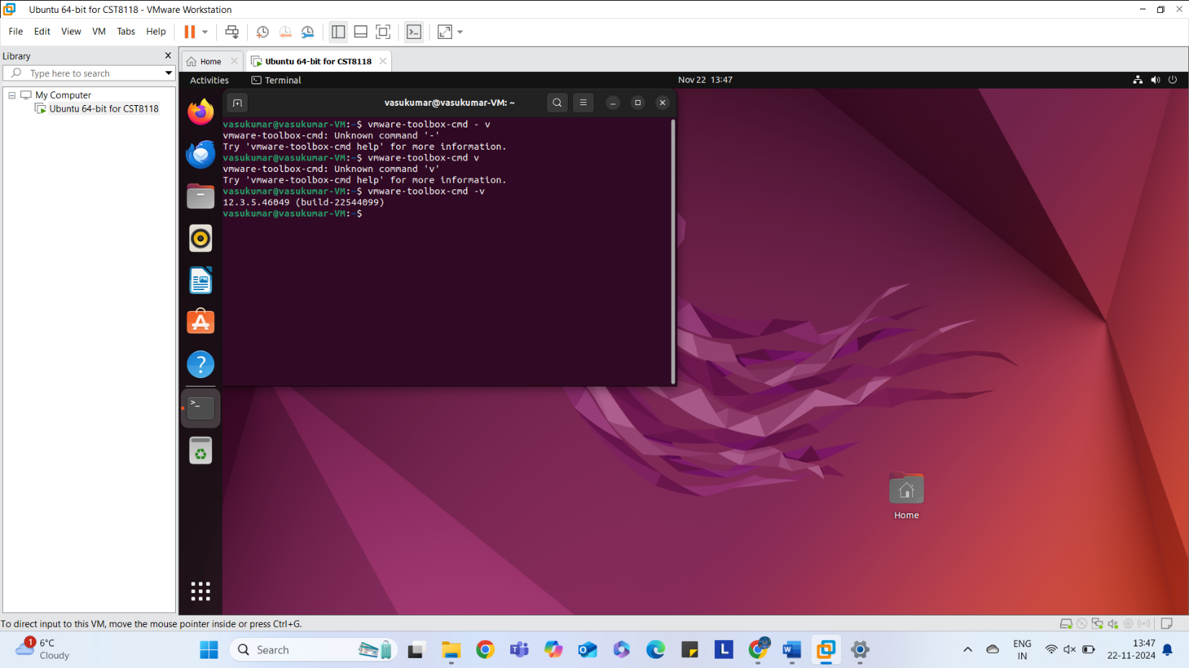

Part 6 Screen Shot: Tree command (1 point)
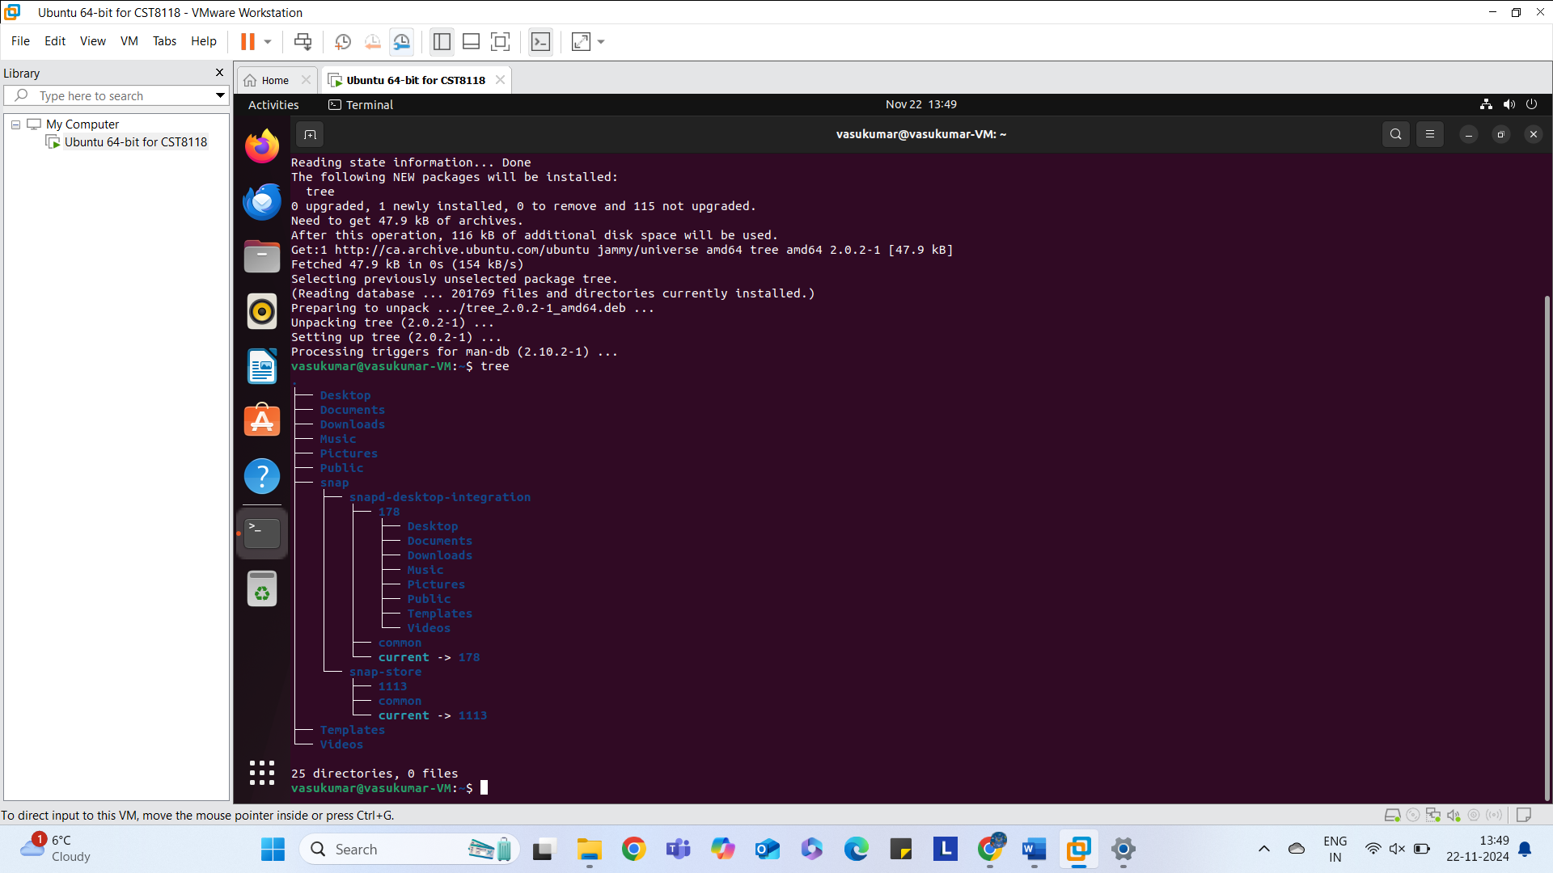

Part 7 Screen Shot: Cloned Virtual Machine (1 point)

